

Tools for a successful Transition

Some children may need additional help to ensure that their transition is as smooth as possible. Research suggests that transitions are central to young children’s development and emotional wellbeing. How the first transitions are handled can have a significant impact on a child’s capacity to cope with change in the short and long term and impact on the progress they make from their starting points.

Neurodiverse children and young people can find transition very difficult due to the change in routine and familiarity. This can include changing schools, year groups and moving onto college or university. It is key that we ensure our children and young people have a positive and planned transition. This helps towards them feeling happy, safe, engaged and ready to learn. Ultimately, we need to make the unknown, known and reduce their anxiety.

SENCO ‘speed-dating’ transition Meeting – DSPL3 will hold it’s (now) annual face-to-face meeting where each Primary School has the opportunity to book time slots with every Secondary school where they have a SEN pupil transitioning to that school. This should ensure sharing of information and discussions of pupil’s strengths and needs to give greater depth of understanding about the pupils that are transitioning to their schools and to generally get to know them better. This may include pupils with or without a diagnosis, and with or without an EHCP. The idea is that by the end of the day almost all pupil information has been passed over from Primary SENCO to Secondary SENCO. This should help cut down time travelling between schools to arrange all these separate meetings and coordinating everyone’s availability and diaries. We will have various other professionals in attendance on hand too that may be useful and relevant to the process. These may be professionals that have previously worked with the families, observed the CYP or given professional advice in some capacity. (First/Middle/Upper Schools also included)

Early Identification
To help ensure a smooth and robust transition from Primary to Secondary School (or lower/middle/upper school), it is first important for those children to be identified by the current school they are attending and ensure they have informed the new school of those pupils. Some children that may be identified could be (but not limited to):
- Pupils with an EHCP
- Pupils on the SEN register
- Pupils with a diagnosis of a learning, SEMH, SLCN or physical need that impacts on their ability to access teaching and learning and maintain emotional and social wellbeing
- Pupils who receive targeted support over and above quality first teaching and reasonable adjustments
- Pupils where an external professional is offering ongoing guidance and strategies
- The SENCO is offering regular and ongoing targeted guidance and strategies to teaching staff to meet the needs of the pupil
- Pupils who receive additional interventions as part of an assess, plan, do review cycle
- Pupils who are accessing Mental Health support, e.g. CAMHs, STEP2, counselling via school or health

What the current school can do:
- Identify all children as above – do not miss any out! Unfortunately, every year secondary schools do have pupils start that clearly have needs and require additional support, but they were completely unaware of them until many months into the new term. If in doubt, speak to the new school about them and decide between you whether you feel an enhanced transition would be appropriate
- Make contact with the DSPL3 Secondary Outreach Teacher (Sheila Kitchen). This can be done as early as year 5, laying the groundwork for what is needed – observations and meetings to discuss needs and what information should be passed over
- Some Primary schools hold an EHCP review meeting in the summer term after allocation so the Secondary SENCO can attend, and targets are secondary adjusted
- Attend the ‘Speed-dating’ transition meeting to individually discuss those SEN children transitioning with the relevant new school and speak about strategies and support currently in place
- Attend the Transition ‘train-the-trainer’ worskhops being delivered by Alison Lindsell in 4 locations

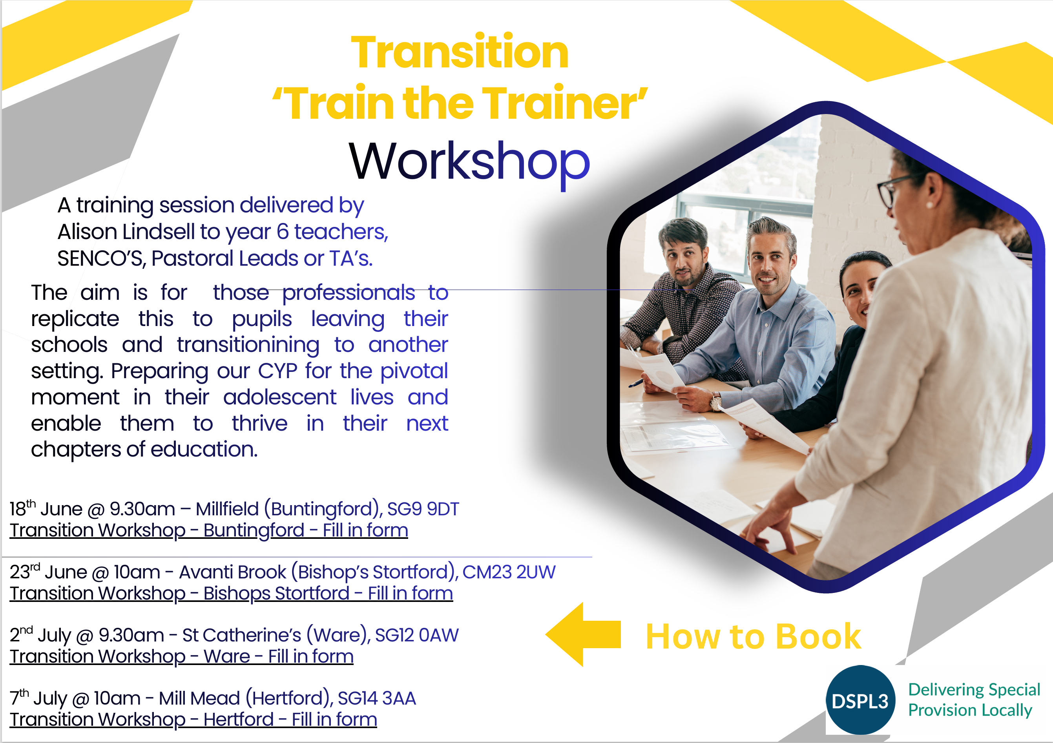

What the new school can do:
- Attend the ‘Speed-dating’ transition meeting to discuss all new children coming to you that need an enhanced transition
- Organise an additional transition day or two, separate and in advance of moving up day, to allow pupils a chance to get to know the school better
- Additional visits could be an after-school session which shows key places and could involve the child using their own device to make a video tour that they can refer to at home. Parents could drop off/pick up at the same point that they will in September
- Invite parents in over the summer term to meet the SEND team
- Offer summer schools to all but especially to those needing an enhanced transition
- Pupil Passport written in collaboration with child, parent and primary school and be disseminated to all teaching staff. Must be concise and meaningful
- Provide an email address and contact so the pupil can ask any questions direct and get a reply. This will be reassuring, reduce anxiety and stress, and give a more personalised transition
- Run a SEND parent coffee morning for new year 7 students – this could be in the summer term of year 6 and/or in year 7
- Provide a map of the school
- Identify SEND areas or safe/quiet spaces
- Photos of familiar places – entrance, canteen, toilets etc.
- List and photos of SEND members of staff/pastoral leads/form tutor/Head of Year etc and how to find and/or contact them
- Video tour/walk through of school
- Recordings of familiar sounds such as the bell ringing
- Break and lunchtime buddy clubs in SEND area
- Equipment list with photos
- School uniform and PE kit list with photos, including second hand uniform contacts
- Example timetable with notes on how to read/understand it

Preparation at home

School uniform
Many neurodiverse children and young people may have clothing sensitivities. We know textures, seams, tags and even fit can cause discomfort and distress. Do not wait until a few days before school starts to try on uniform and PE kits. Get your child used to dressing/undressing with their new uniform especially buttons, shirts, ties, mouth guards etc. Also allow them to familiarise themselves with the new feel and textures of the clothing by wearing it around the house multiple times throughout the summer. Wash it and cut out tags as necessary. Make sure to include those new school shoes and PE trainers too, so they are nicely broken in and not rubbing once school starts. Consider buying pre-loved school uniform as this will have a softer texture. It is also important to have conversations with the SENCO at the secondary school regarding uniform and clothing sensitivities, to discuss possible alternatives and reasonable adjustments that can be made in advance of purchasing school uniform.

First day photos
Your child will already be feeling anxious and nervous on their first day of school. Do not wait until then to take first day pictures. Choose a day during the summer holidays to take those pictures instead – you will both be feeling less stressed for it.

School bag & equipment
Pack and re-pack your child’s school bag with them several times until they feel confident doing it independently. Keep a check list of equipment so they can check against it and even take a photo of the bag and its contents for your child to refer back to. Clear pencil cases can help with a visual check for equipment for your child and any staff who are supporting them.

Journey to school
Practice the journey to school many times. Whether it’s walking, driving or taking the bus, practise the same route every time. You can also point out the same landmarks each time so your child can familiarise themselves with the journey and surroundings.

Calendar
Use a calendar across the summer to indicate the countdown to school. You can use this to mark days going to buy uniform, days to practise wearing it, purchasing stationery and equipment and packing school bags. Make sure to also highlight fun days out to look forward to, this will help make the holidays more predictable and minimise anxiety.

Joining groups
Consider joining year 7 WhatsApp or Facebook groups and engage with PTA’s or local parent support groups. Encourage your child to meet up with any friends that are going to the new school to help build friendships.

Things to do
Spend time learning the school map – consider colour coding important rooms such as library, canteen, form room, toilets, SEND area etc. Watch a video tour if available and familiarise yourself with any photos of the building and staff members. Learn how to read a timetable and personalise it – this could be using symbols for different subjects, clock faces for time to make it more visual and easier to read in a glance. Consider marking key landmarks on your map, photo route cards or bulleted instructions to help get round the school.

What to expect:
- A lot more teachers
- A lot more students
- A lot more classrooms / bigger playground and outdoor space
- More subjects to understand
- A noisy and larger canteen with more food choices
- New uniform with more fastenings and stiffer feeling
- A locker to keep your things in instead of a peg
- More equipment to carry in your bag
- Travelling independently to school
- Different toilets
- More choices

Timeline
2nd March 2026 – National Allocation Day
1st May 2026 – Final Continued Interest Run
5th May 2026 – ‘Speed-dating’ Transition Meeting for ALL SENCO’s
June & July – Transition ‘train-the-trainer’ workshops for year 6 teachers/SENCO’s
June & July – Additional transition days
9th July 2026 – Transition Day for all pupils

Useful documents:
It is really helpful for the student to be given a booklet which contains all the important and useful information that they will need to get them off to a good start. This will help reduce anxiety and will allow them to refer back to it at any point.

Over the next pages are some examples of information that can be used by schools and/or given to the CYP or parent/carer.

All of this information is also available on our website: www.DSPL3.org.uk

Dear Parent/Carer,
Re: Support Transition for Year 6 pupils to Insert School Name

Firstly, let me introduce myself, my name is Insert name and I am the Director of Inclusion (SENCO) at Insert school name. I look forward to meeting and working with you all.
Transition to secondary school can be an extremely anxious time for our students and parent carers. The fact that they are moving to a new school, with new staff and routines can be difficult for many students. To help to ease this anxiety and begin to prepare students for September, in addition to our Transition Day on Thursday 10th July, we are going to be running several transition visits. Each transition visit will be for a short period of time, to support students for whom the experience of a whole day can be too much for their first visit to the school. I also want to make sure that they have someone familiar with them, so I am inviting parents and TAs to attend with them. The timetable for the visits is stated below:

Session 1- Insert date 3.30pm – 5pm - Tour of the school, opportunity to take photos to help them recognise and remember their new environment, meet new staff. Parents welcome.
Session 2- Insert date 10.30am -12pm - Classroom based activities- including getting to know you activities. Support from TA required. Please confirm by email intended attendance.
Session 3- Thursday 10th July- All students transition day, all day (more details for this will follow).
(There may be other sessions, if it’s felt necessary)

I look forward to meeting with you and welcoming you all to the school. If there are any issues or questions, please don’t hesitate to email me on Insert email address.

Regards
Insert name (SENCO)

Important Information: Staff

You can find a full list of staff members on the Name of School website Insert website link to staff list, but here are a few names you might want to know for September!

Head Teacher: Insert name and photo

Head of Year 7: Insert name and photo

SEND department:
SENCO - Insert name and photo
Pastoral Lead - Insert name and photo
SEMH Lead - Insert name and photo
Autism Lead - Insert name and photo
Senior Learning Support Assistant - Insert name and photo
Learning Support Assistants - Insert names and photos

Safeguarding: Insert names

* Consider including how/where to contact them

Map of School
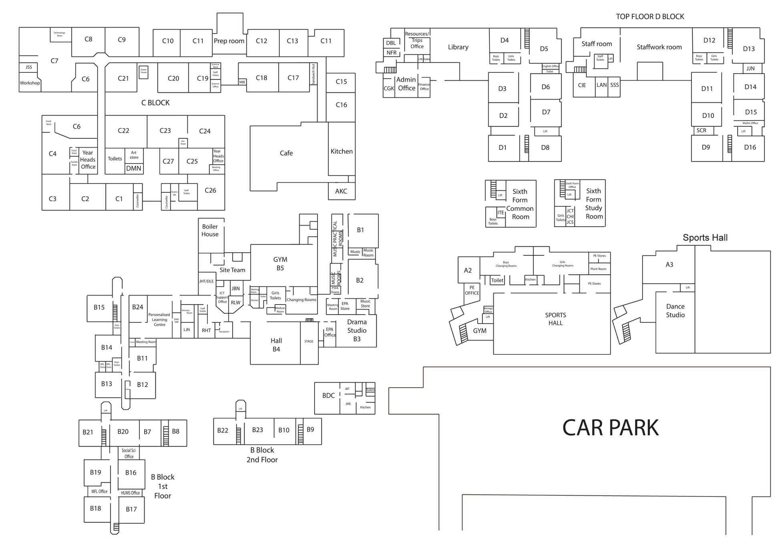
Important Information: Rooms

School building/entrance (Insert photo):

Form room/classroom (Insert photo):

Library (Insert photo):

Canteen/dining hall (Insert photo):

Main Hall (Insert photo):

Sports Hall (Insert photo):

Outdoor spaces (Insert photo):

Learning support room/quiet space (Insert photo):

Any other classrooms such as Science lab, DT, Food technology, ICT, Drama studio (Insert photos):
Equipment you will need at secondary school

It is important that you come to school ready with all of the things you might need. Here is a checklist you can use when you pack you bag for the first time!



Black pens Scientific calculator


Blue pens Pencil sharpener




Pencils Pencil case




A rubber Water bottle

A ruler School bag
School Uniform
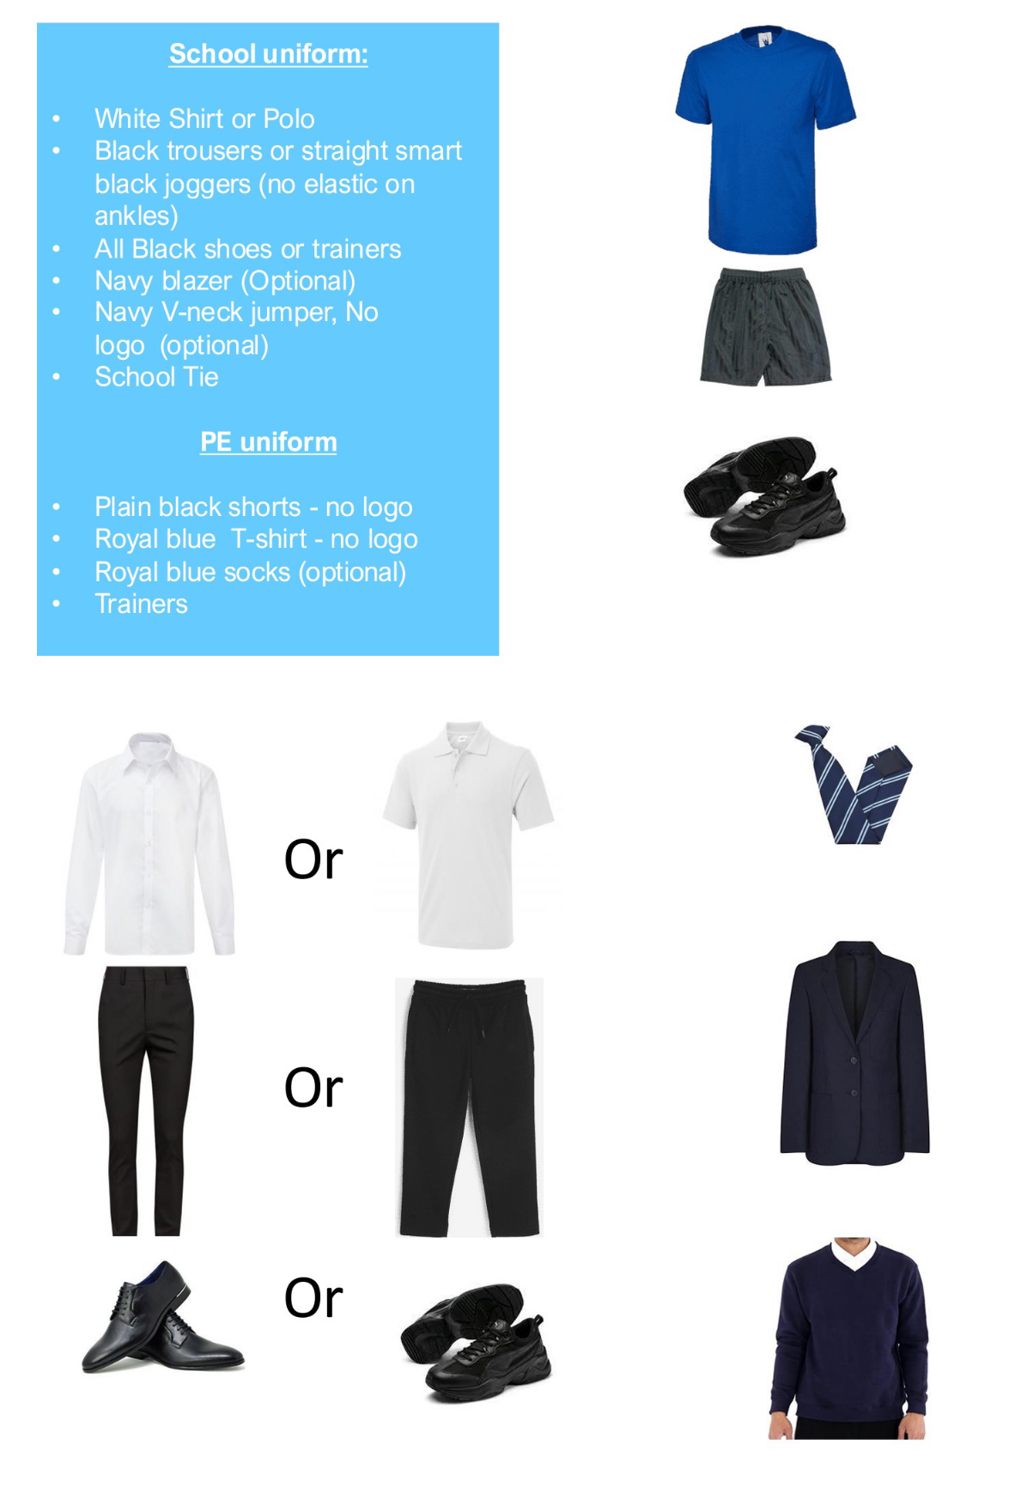
It is important that you come to school in the correct uniform and have the correct PE kit. Here is a checklist you can use:
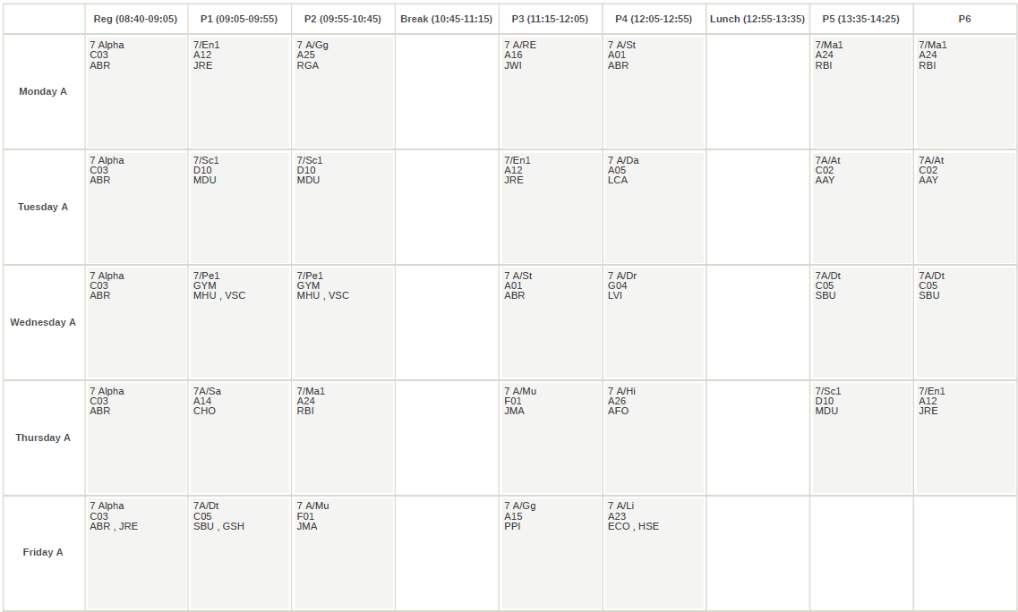
Timetable
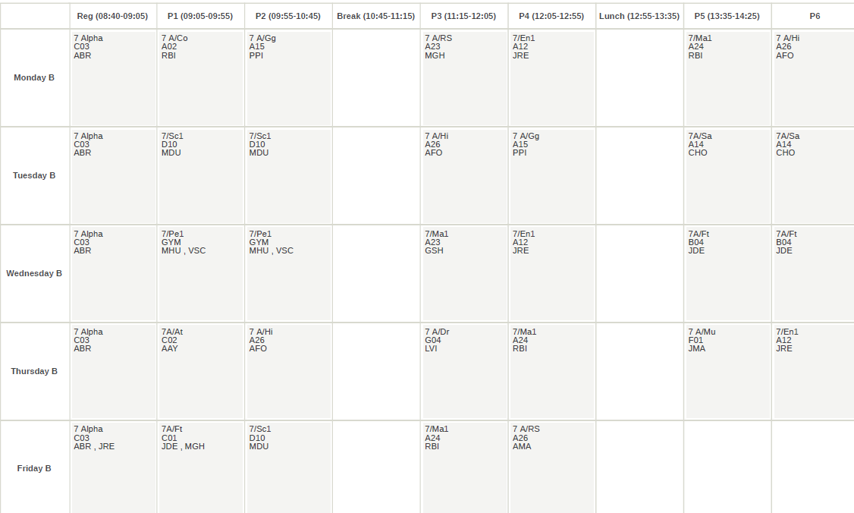
Below is an example of a timetable from the current year 7. Yours will look slightly different, but it might help to see how your lessons will be laid out for next year (insert a copy of your schools timetable and a key).
As you can see from the example above, most secondary schools run a two-week timetable. Please ensure that you know which week you are on, so you have the required equipment and attend the correct classes.

Timetable key:
Using one of the examples above, this is how to understand your timetable:
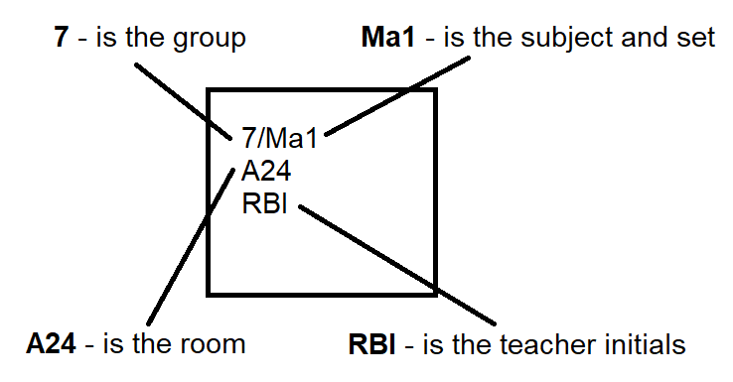

The School Day:
Arrive at school: 8.25am
Registration: 8.30am – 8.40am
Lesson 1: 8.40am – 9.40am
Lesson 2: 9.40am – 10.40am
Break: 10.40am – 11.00am
Lesson 3: 11.00am – 12.00pm
Lesson 4: 12.00pm – 1.00pm
Lunch: 1.00pm – 2.00pm
Lesson 5: 2.00pm – 3.00pm
Registration: 3.00pm – 3.30pm
End of the day: 3.30pm

